Practice
A.Role play / write a dialogue for the following situations with a partner.
Include details and givea variety of response.
1. invite your partner to go fishing this weekend.
2.invite your partner to your home for dinner.
3. invite your partner to see the circus.
4. invite your partner to attend your violin concert.
5. invite your partner to attend a political rally.
B. Choose the correct response
1. Is ten OK with you?
a) isn’t it a bit late? b) in half an hour.
2. What about seven?
a) Ok, then. B) Come on.
Accepting and refusing politely may depend on what you are asked. For example
Would you like some cake?
Yes, please.  Sure. Thanks  Okay. Thank you |  | No, thank you  I'd better not.  No, but thanks for offering.

Would you like to go see a movie?
Okay. Sounds good.  Sure. I'd love to.  Yeah. Good idea |  | No, I'd rather not.  I'm sorry, but I can't.  No, but thanks for inviting me.

How about some more pie?
All right. Thanks  Looks good. Thanks  Don't mind if I do. |  | No, thanks.  I'm really full. Thanks anyway.  Looks delicious, but I'll have to pass.

How about going skiing this weekend?
Great. What time?  Sounds like fun.  All right. When and where? |  | Sorry. I'm busy this weekend.  I don't think I can.  How about some other time?

Accepting, and Declining an Invitation

Which of the following answer is NOT appropriate?
1. Wanna come over for dinner tonight?
1. ? Sure. What time?
2. ? Why not? When should I be there?
3. ? Why?
2. Wanna come over for a quick meal tonight?
1. ? No.
2. ? I'd love to, but I have an appointment.
3. ? I'm busy tonight. Can I take a raincheck?
3. My husband and I were wondering if you'd like to come over for dinner this Saturday.

1. ? Thank you very much! I'd be delighted to.
2. ? I'd love to, but I'm afraid I'm busy this Saturday.
3. ? I don't go out on Saturdays.
4. A: Would you care to join us for dinner tonight?
1. ? Yes, I would.
2. ? Thank you. I'd love to.
3. ? I'm sorry but I already have plans tonight.
5. : Tonight is no good. Can I take a raincheck?
1. ? OK. No problem.
2. ? Sure. Let's do it some other time.
3. ? No, you can't.
6. Do you want me to bring something?
B: _____
1. ? No, just bring yourself.
2. ? Why? You don't like my cooking?
3. ? OK, bring some dessert if you want.

(d) Invitation & Replies
Main characteristic of invitation
Invitation can be both formal and informal
They can be printed on cards or can be drafted as social letter.
A single sentence presentation in third person, in case of a formal invitation of fist/second person in case of an informal invitation.
It answer who, when, where, what time and for what i.e.
(a)The occasion
(b) Names of the invite
(c)Name of the host
(d) Date, time and venue
The other details include mane, designation and address of the organizer, sponsor of host or names of special guest and invitees in case of and official invitation.
The Principal Staff and Students of
Delhi Public School, Ghaziabad
cordially invite you to the
“ANNUAL SPORTS DAY CELEBRATION”

on Saturday the 10th November 2006 at 10 A. M. at the school ground
Shri N. M. Singh Distt collectors has consented to be the chief Guest.

RSVP

Principal 0744-288255
Formal (letter type)
It is just like a standard formal letter and then students should be guided to write as given below.
Delhi public school
Ghaziabad
5-11-2006
Shri K.J. Sharma
D.G.P. – Ghaziabad
Sub: initiation annual sports day celebration
Sir,
We are pleased to inform you that our school is celebrating. …………………………………………............................................................
……………………………………………………………………………………………………………
Soliciting a line in reply or call on us/ do attend and make it a success.
Your Faithfully
Sd/

Principal

Informal Invitation
N.B. It is to be written in first/ second person. Other characteristics are same as that of formal one. The format is just like that of a personal letter
Senders address
Date
Salutation
Body
Complementary close
Name of the sender

12 A. C. Nagar
Delhi
10th November 2011
Dear Ashok
Would you like to join us ………………………………………………………………………………...
……………………………………………………………………………………………………………..

Hope to see you soon

With warm regards
Anil Malhotra
Replies:
- Replies are again two types formal and informal. It can be written in either in card type or in letter type.
- It is meant for accepting an invitation or to show inability to attend it

Formal reply – (written in third person)
Acceptance (card type)
Mrs. and Mr. S. N. VERMA

Accept with pleasure the kind ---------------------------------- - -------------------------------------------------------------
At
- -----------------------------------------
On ------------- at their residence

S. N. VERMA
10-11-2010

Regret (card type)
Mrs. & Mr. S. N. VERMA

Regret their inability --------------------------------
---------------------- at dinner
On--------------------- because of prior engagement
S. N. VERMA

10-11-2010

Formal reply (letter type)
12, AB Nagar
Kolkata
10th November 2010
Sir

Mr. & Mrs. V.K. Verma………………………………………………………………………………….
……………………………………………………………………………………………………………
How even they express their inability to be present -----------------------------

With best wishes
V. K. VERMA

N.B.- For informal replies the format is same like the one given above only the language and person ( first & second) are ,different.

Modal Verb
A modal verb, also known as an auxiliary verb, is a kind of kind of special verb which behave very differently and irregularly from normal verbs. Modal verbs are used, to describe what the speaker thinks about a particular situation, whether it is possible or not possible and so on. The modal verbs ‘can, will, shall, ought to, must, need may’ are used with the present tense while could, would, should, might are modal verbs used in the past tense.

What is the function of a Modal Verb?
The modal verbs “can, could, may, might” can be used in various situations to indicate.
- Ability or possibility :They can lift their own bags or I might be back by noon.
- Asking for permission :Can I sit here? or
You may watch T.V. after doing your homework.
- Inability or impossibility : The plumber can’t fix the leak . or
I cannot go to the party tomorrow.
- Making a request : Can you shut the window. Or
May I come with you to the store?

How are modal verbs different from normal verbs?
The third person of a modal verb does not take a “-s” as is the practice in normal verbs.
- She can write good English.
- He will leave the hotel tonight.

How is the modal verb "would" used?
The modal verb ‘would’ has a variety of uses to indicate invitation, conditional, permission, request, question, habit, suggestion. Would is used in the contracted form as ‘d’. The negation is formed by adding not as in would not or wouldn’t.
- I would like a cup of coffee (request)
- I would play if I could (conditional)

How are modal verbs made negative?
Modal verbs are made negative by adding the word “not” even in the simple present and past tenses.
- She should not travel by air.
- They could not attend the wedding.

Can we use modal verbs in the future tense?
It would be incorrect to use certain modal verbs in the past or future tenses, for example modal verbs such as can and must retain their form irrespective of the tense.

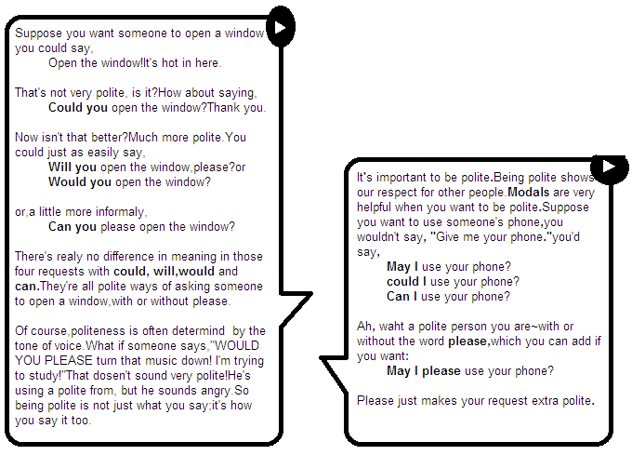

Requesting
MORE FORMAL | LESS FORMAL
Use shall or would you like to suggest or invite someone to do something. | Use let's, why don't we or how about to suggest or invite someone to do something in a less formal situation.
Shall we go outside? | Why don't we go outside?
Would you like to go to a table outside? (Would you like + NP or infinitive) | How about going outside? (very informal)
Let us pray. (very formal, not commonly used) | Let's go outside?

Suggestion / Invitation

Asking people to do things (requests)  We often use can or could to ask people to do  things:  - Can you wait a moment, please? or  Could you wait a moment, please?  - Liz, can you do me a favor?  - Excuse me, could you tell me how to get to  the station?  - I wonder if you could help me.  Note that we say ‘Do you  think (you) could…?’ (not usually ‘can’):  - Do you think you could lend me some money until next week? | 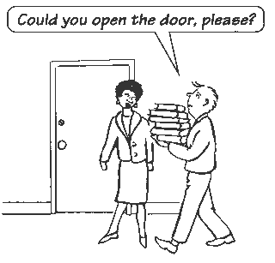
To ask for permission to do something, we use can, could or may:
- (on the phone) Hello, can I speak to Tom, please?
- ‘Could I use your phone?’ ‘Yes, of course.’
- Do you think I could borrow your bike?
- ‘May I come in?’ ‘Yes, please do.’
To give permission, we use can or may.
- You can use the phone. or You may use the phone.
May is formal and less usual than can or could.
Offering to do things
To offer to do something, we sometimes use Can I…?:
- ‘Can I get you a cup of coffee?’ ‘Yes, that would be very nice.’
- ‘Can I help you?’ ‘No, it's all right. I can manage.’

